**References and Result**

For this challenge, I used a Free tier EC2 Linux Instance and setup followings on EC2 instance

* Docker
* Git
* A docker container for PostgreSQL DB
* A docker container for Python environment

All the steps used to perform above actions are committed in below github repository

<https://github.com/manudu20/crmRepo.git>

Following websites were referenced during the assignment.

* To install postgresql on docker

<https://docs.docker.com/samples/postgresql_service/>

* To install psycopg2 dependencies

<https://stackoverflow.com/questions/62715570/failing-to-install-psycopg2-binary-on-new-docker-container>

* To convert Data frame into csv for each row.

<https://stackoverflow.com/questions/58377674/make-csv-file-from-each-row>

**Please check the Results of Table and View of Blogs**

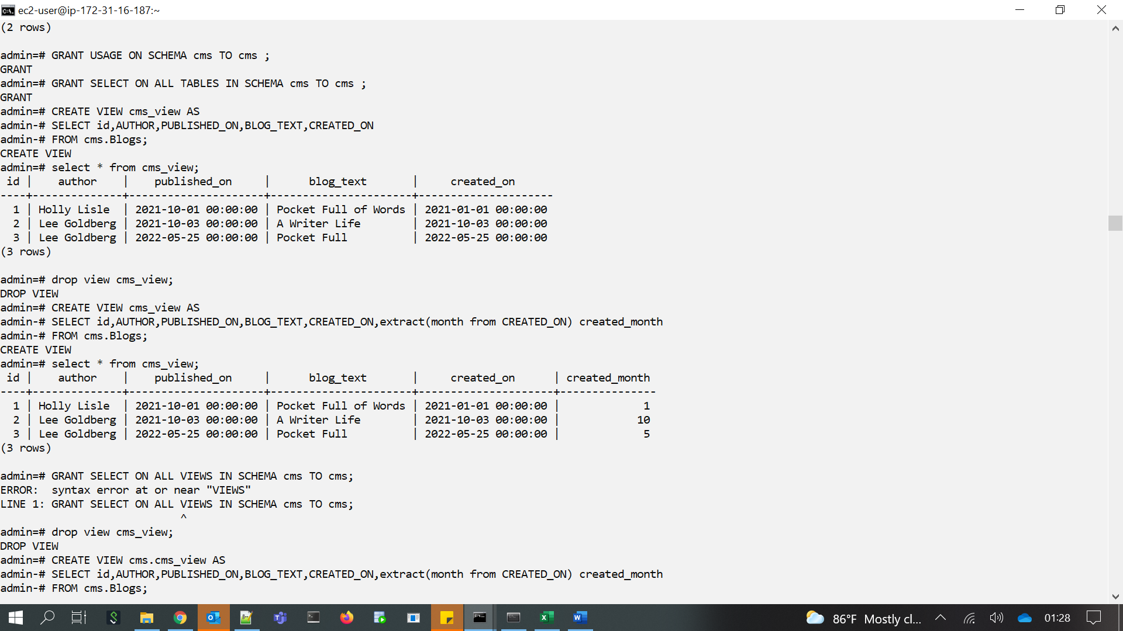



**The result of python script**

